TEAM:PNT2022-TMID26748

# #Performance Analysis (sprint-3) (i).Performance Analysis

metrics = pd.DataFrame(model.history.history) metrics

loss accuracy val_loss val_accuracy 0 0.136240 0.959183 0.054753 0.9811

1 0.048557 0.985233 0.049157 0.9839

2 0.030406 0.990800 0.043443 0.9861

3 0.020990 0.993350 0.047409 0.9850

4 0.013883 0.995450 0.038858 0.9890

5 0.011308 0.996183 0.046504 0.9865

6 0.008813 0.996933 0.045933 0.9875

7 0.005928 0.997917 0.044267 0.9886

metrics.plot()

<matplotlib.axes._subplots.AxesSubplot at 0x7f9be00620d0>

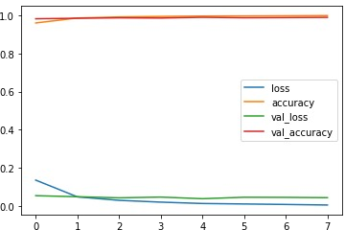

metrics[['loss','val_loss']].plot()

<matplotlib.axes._subplots.AxesSubplot at 0x7f9b8a38eb90>

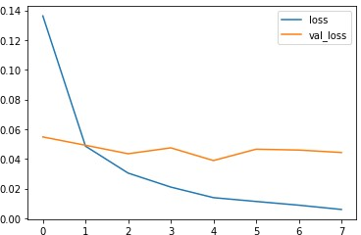

metrics[['accuracy','val_accuracy']].plot()

<matplotlib.axes._subplots.AxesSubplot at 0x7f9b8a2a36d0>

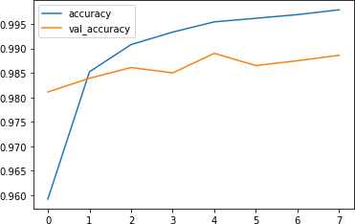

# (ii).Evaluate the Model

model.evaluate(x_test,y_cat_test,verbose=0)

*#loss | #accuracy*

[0.04426722601056099, 0.9886000156402588]

from sklearn.metrics import classification_report,confusion_matrix

predict_x=model.predict(x_test) classes_x=np.argmax(predict_x,axis=1)

313/313 [==============================] - 1s 2ms/step

print(classification_report(y_test,classes_x))

|  |  |  |  |  |
| --- | --- | --- | --- | --- |
|  | precision | recall | f1-score | support |
| 0 | 0.99 | 1.00 | 0.99 | 980 |
| 1 | 0.99 | 1.00 | 1.00 | 1135 |
| 2 | 0.99 | 0.99 | 0.99 | 1032 |
| 3 | 0.98 | 1.00 | 0.99 | 1010 |
| 4 | 0.99 | 0.98 | 0.99 | 982 |
| 5 | 1.00 | 0.99 | 0.99 | 892 |
| 6 | 0.99 | 0.98 | 0.99 | 958 |
| 7 | 0.98 | 0.99 | 0.99 | 1028 |
| 8 | 0.99 | 0.98 | 0.99 | 974 |
| 9 | 0.98 | 0.98 | 0.98 | 1009 |
| accuracy |  |  | 0.99 | 10000 |
| macro avg | 0.99 | 0.99 | 0.99 | 10000 |
| weighted avg | 0.99 | 0.99 | 0.99 | 10000 |

print(confusion_matrix(y_test,classes_x))

|  |  |  |  |  |  |  |  |  |  |  |
| --- | --- | --- | --- | --- | --- | --- | --- | --- | --- | --- |
| [[ | 977 | 0 | 0 | 1 | 0 | 0 | 1 | 0 | 1 | 0] |
| [ | 0 | 1132 | 1 | 2 | 0 | 0 | 0 | 0 | 0 | 0] |
| [ | 1 | 1 | 1017 | 2 | 0 | 0 | 2 | 7 | 2 | 0] |
| [ | 0 | 0 | 1 | 1005 | 0 | 1 | 0 | 1 | 1 | 1] |
| [ | 0 | 0 | 0 | 0 | 963 | 0 | 1 | 0 | 0 | 18] |
| [ | 0 | 0 | 0 | 12 | 0 | 879 | 1 | 0 | 0 | 0] |
| [ | 4 | 2 | 1 | 0 | 4 | 2 | 943 | 0 | 2 | 0] |
| [ | 0 | 2 | 5 | 0 | 0 | 0 | 0 | 1019 | 1 | 1] |
| [ | 4 | 0 | 1 | 6 | 0 | 0 | 0 | 1 | 959 | 3] |
| [ | 0 | 1 | 0 | 1 | 5 | 1 | 0 | 9 | 0 | 992]] |

import seaborn as sns plt.figure(figsize=(10,6)) sns.heatmap(confusion_matrix(y_test,classes_x))

<matplotlib.axes._subplots.AxesSubplot at 0x7f9b73f53750>

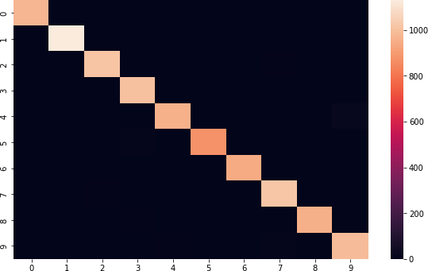

(iii).Make Prediction my_num = x_test[1] classes_x

array([7, 2, 1, ..., 4, 5, 6])

plt.imshow(my_num.reshape(28,28))

<matplotlib.image.AxesImage at 0x7f9b73a95b10>

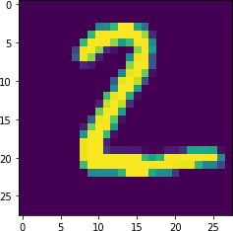

# (iv).Save the Model

from tensorflow.keras.models import load_model

model.save('CNN.h5') print('Model Saved!')

savedModel=load_model('CNN.h5') savedModel.summary()

Model Saved!

Model: "sequential"

Layer (type) Output Shape Param #

=================================================================

conv2d (Conv2D) (None, 25, 25, 32) 544

|  |  |  |  |  |
| --- | --- | --- | --- | --- |
| max_pooling2d (MaxPooling2D  ) | (None, 12, 12, | | 32) | 0 |
| flatten (Flatten) | (None, | 4608) | 0 | |
| dense (Dense) | (None, | 128) | 589952 | |
| dense_1 (Dense) | (None, | 10) | 1290 | |

=================================================================

Total params: 591,786

Trainable params: 591,786

Non-trainable params: 0